CSIT314 Software Development Methodologies - Group Project

Sprint 1 - US5: Update user profile
Interior Design Platform - User Admin
All diagrams were drawn in draw.io. Open "US5 Update user profile.drawio" in this folder to edit them - each diagram is its own page in that file. The exported images are in the "diagrams" folder.

Assumptions
- The system is the Interior Design Platform from the project specification. This sprint covers the User Admin's log in / log out and managing user profiles.
- A user profile is a user group, e.g. User Admin, Interior Designer, Customer or Platform Manager. It has a name, a description, a list of permissions (what its users can do) and a status (Active or Suspended). Every user account belongs to exactly one user profile and gets that profile's permissions.
- We follow B-C-E: the actor only talks to the boundary (page), the boundary only talks to the controller, and the controller works with the entity classes. There is one controller per use case.
- Simple input checks (empty fields, length) are done in the boundary. Business rules (e.g. unique names) are done in the controller. Entity classes read and write the database.
- The same rules as creating a profile apply: the name is 3-50 characters, it must be unique (capitals don't matter) and at least one permission must be ticked. A profile can keep its own name.
- The status is not changed here. Suspending is a separate story (US6), so updating a suspended profile leaves it suspended.
- The permissions belong to the profile, so after an update every user account in that group has the new permissions.

1. User story
Story ID | US5
User story | As a user admin, I want to update a user profile so that the group's details and permissions stay up to date.
Actor | User Admin
Priority | Medium
Story points (estimate) | 3
Acceptance criteria | 1. Given I am viewing a user profile, when I click "Update", then a form opens with the current name, description and permissions already filled in.  2. Given I change the details and the input is valid, when I click "Save changes", then the changes are saved and I see "User profile updated successfully" with the new details.  3. Given I keep the same name and only change other things, then it saves (it is not treated as a duplicate).  4. Given I change the name to one another profile already uses, when I click "Save changes", then nothing is saved and I see "A user profile with this name already exists".  5. Given the name is empty or the wrong length, or no permission is ticked, then nothing is saved and the problem fields are highlighted.  6. Given I click "Cancel", then nothing changes.
Tasks | T5.1 Write the use case description and draw the use case diagram  T5.2 Draw the B-C-E class diagram and the sequence diagram  T5.3 Draw the wireframes for the details page, the update form, the error state and the success state  T5.4 Write the unit tests first (TDD) for UserProfile.isProfileNameTaken(name, id), updateUserProfile() and UpdateUserProfileController  T5.5 Code UserProfile.isProfileNameTaken(profileName, profileId) and updateUserProfile()  T5.6 Code UpdateUserProfileController  T5.7 Code UpdateUserProfilePage: pre-filled form, input checks and messages  T5.8 Run the test cases, fix bugs and push to the repo so the CI pipeline runs the unit tests

2. Use case diagram
The user story becomes one use case, UC5 Update user profile. The User Admin is the only actor.
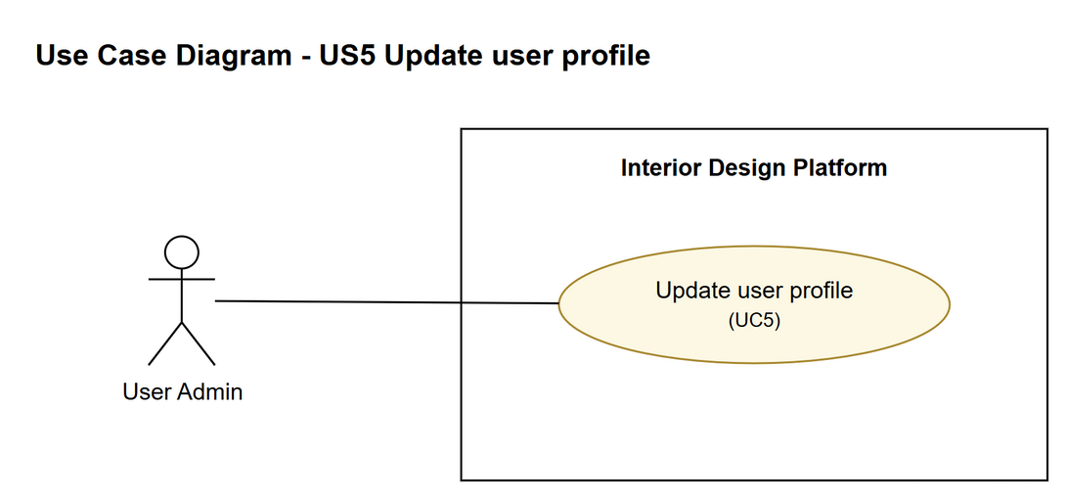
Figure 1: Use case diagram for US5 Update user profile

3. Use case description
Use case | UC5 Update user profile
Actor | User Admin
Brief description | The User Admin changes a user profile's name, description or permissions.
User story | US5: As a user admin, I want to update a user profile so that the group's details and permissions stay up to date.
Preconditions | The User Admin is logged in (UC1).  The user profile exists and the User Admin is viewing it (UC4).
Trigger | The User Admin clicks "Update" on the user profile's details page.
Basic flow | 1. The User Admin clicks "Update".  2. The system gets the profile's current details and the list of permissions.  3. The system shows the update form filled in with the current details.  4. The User Admin changes the name, description and/or permissions and clicks "Save changes".  5. The system checks that the name is 3-50 characters and at least one permission is ticked.  6. The system checks that no other user profile already has this name.  7. The system saves the changes.  8. The system shows "User profile updated successfully" and the updated details.
Alternative flows | 4a. The User Admin clicks "Cancel": nothing is changed and the details page is shown again.  5a. The name is missing or the wrong length, or no permission is ticked: the system highlights the fields with a message (back to step 4).  6a. Another profile already has this name: the system shows "A user profile with this name already exists" (back to step 4).
Postconditions | The user profile has the new details.  Every user account in this group now has the updated permissions.

4. Wireframes
The wireframes were drawn in draw.io. They are low-fidelity: they show the layout and the flow, not the final colours. The orange numbers match the notes under each screen.

4a - User profile details
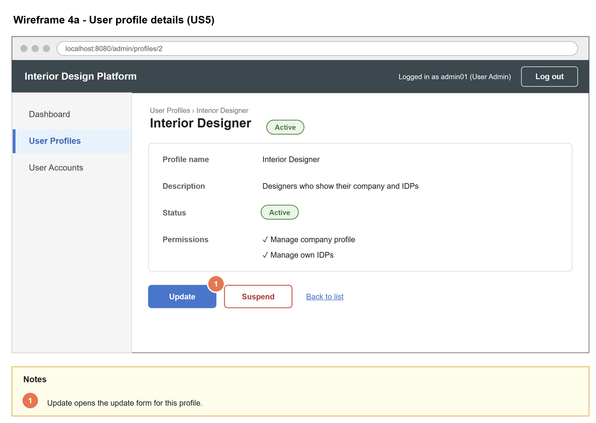
Figure 2: Wireframe 4a - User profile details (US5)

4b - Update user profile form
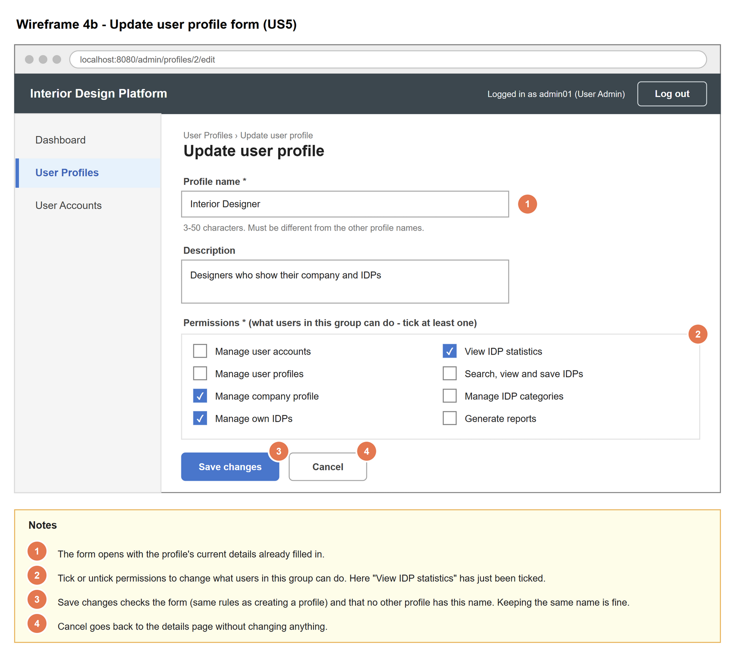
Figure 3: Wireframe 4b - Update user profile form (US5)

4c - Name already used
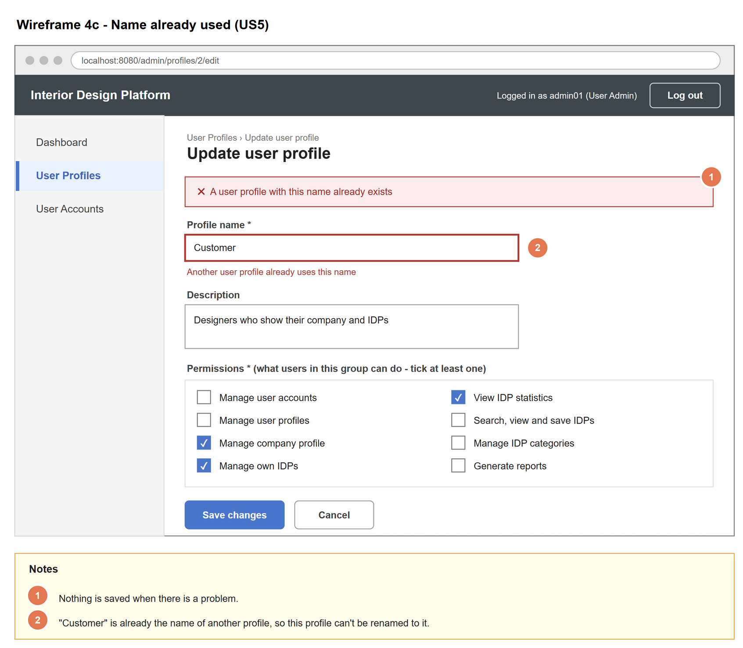
Figure 4: Wireframe 4c - Name already used (US5)

4d - User profile updated
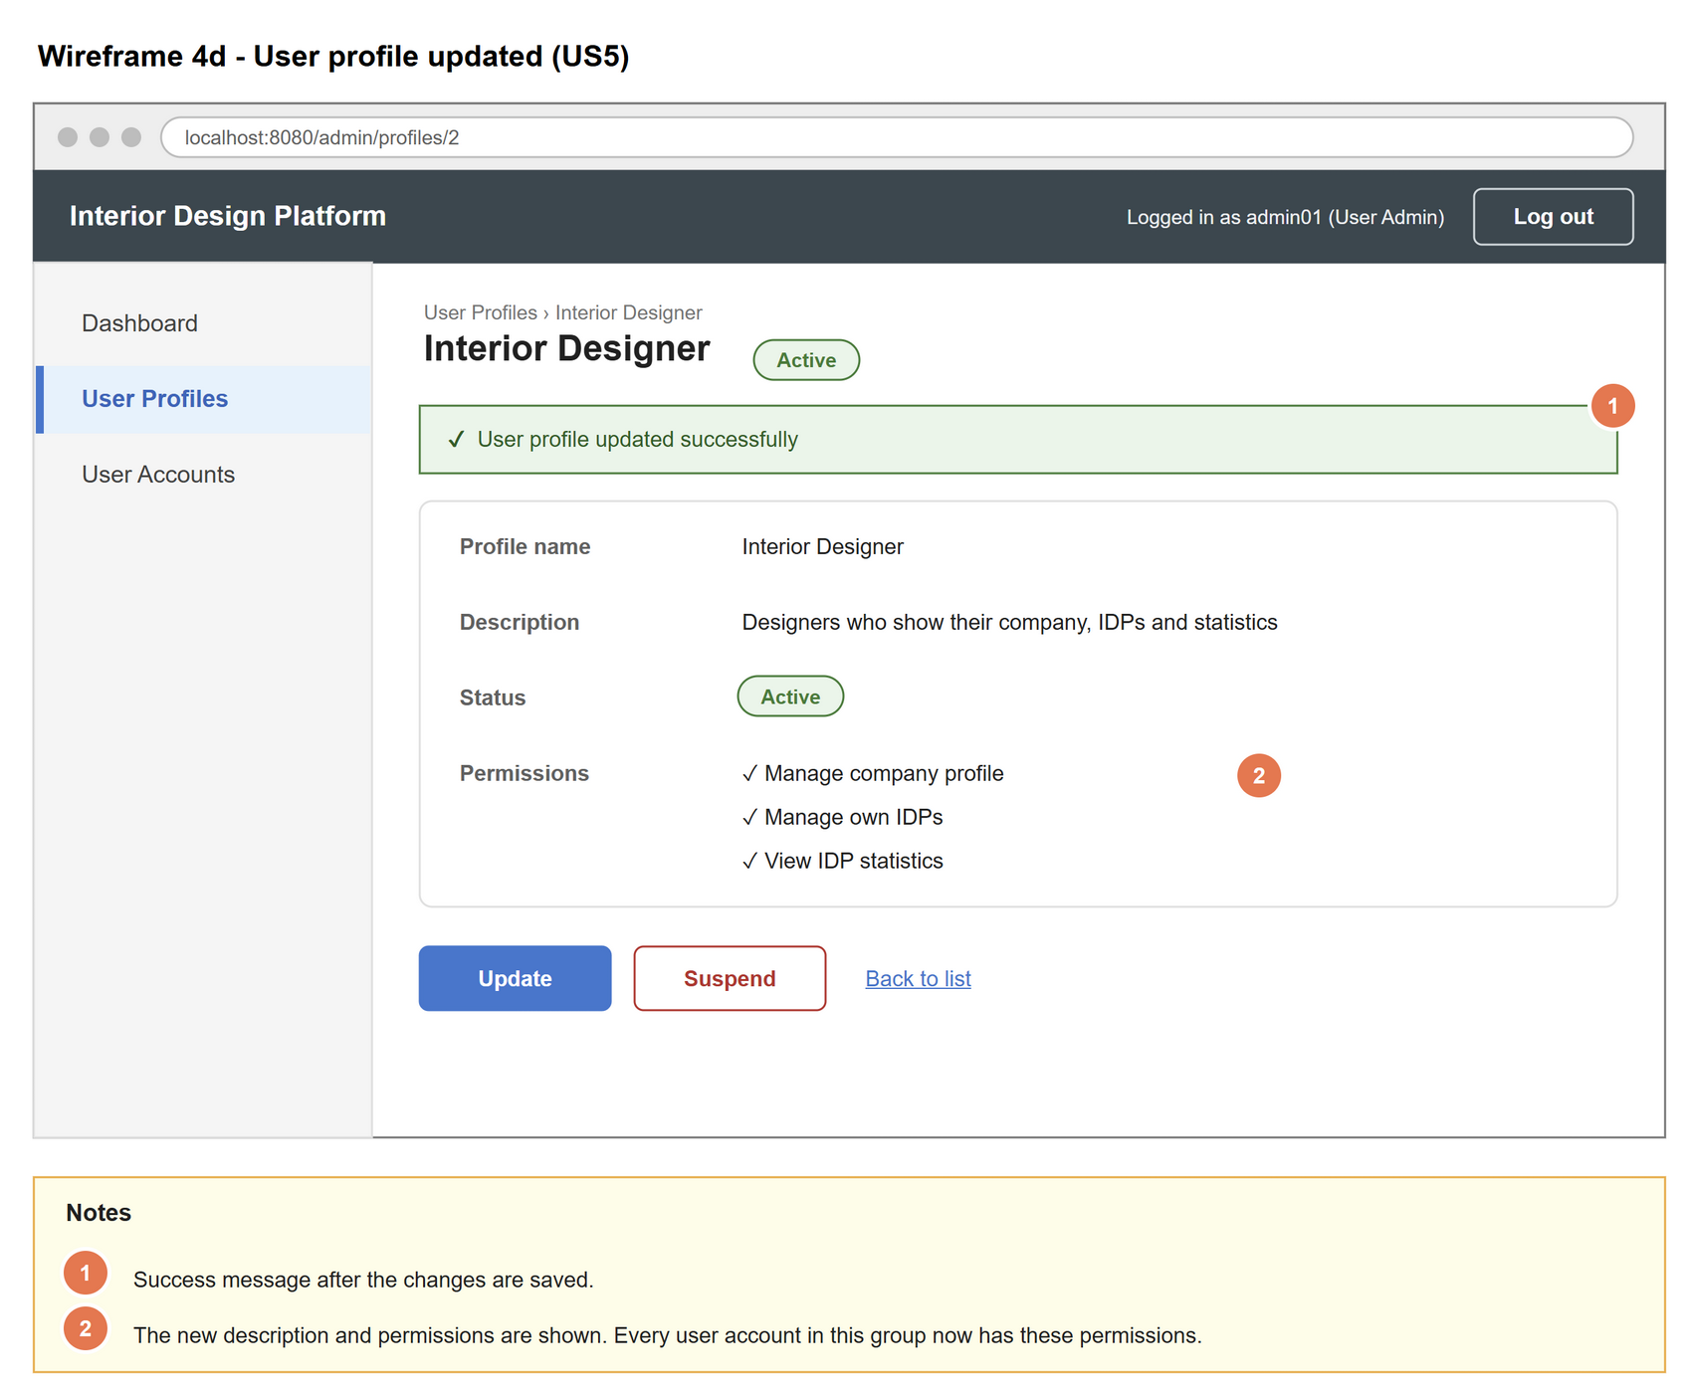
Figure 5: Wireframe 4d - User profile updated (US5)

5. B-C-E class diagram
The solid arrow means the boundary calls the controller. The dashed arrows mean the controller uses the entity class. Only the operations needed for this use case are shown.
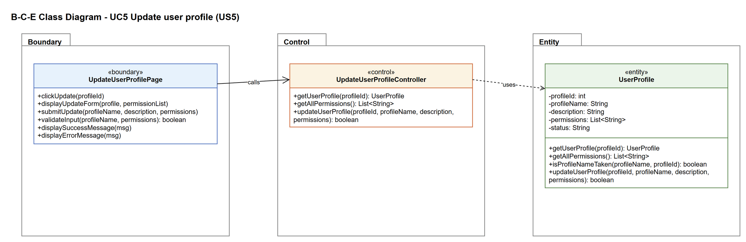
Figure 6: B-C-E class diagram for US5 Update user profile
Layer | Class | What it does
Boundary | UpdateUserProfilePage | The update form. Shows the current details, checks the input, and shows the success or error message.
Control | UpdateUserProfileController | Controller for UC5. Loads the profile and the permission list for the form, then checks that no other profile has the new name before asking UserProfile to save the changes.
Entity | UserProfile | The user group. isProfileNameTaken(name, id) ignores the profile being updated, so a profile can keep its own name. updateUserProfile() saves the changes but never changes the status.

6. Sequence diagram
Messages 1-10 are steps 1-3 of UC5: the page loads the current profile and the permission list through the controller and shows the filled-in form. After the User Admin submits it, the outer alt splits on the page's input check (alternative flow 5a). The controller then checks the name is not used by a different profile (step 6) and saves the changes in the opt box (step 7). The inner alt shows the success message (step 8) or the "name already exists" message (alternative flow 6a).
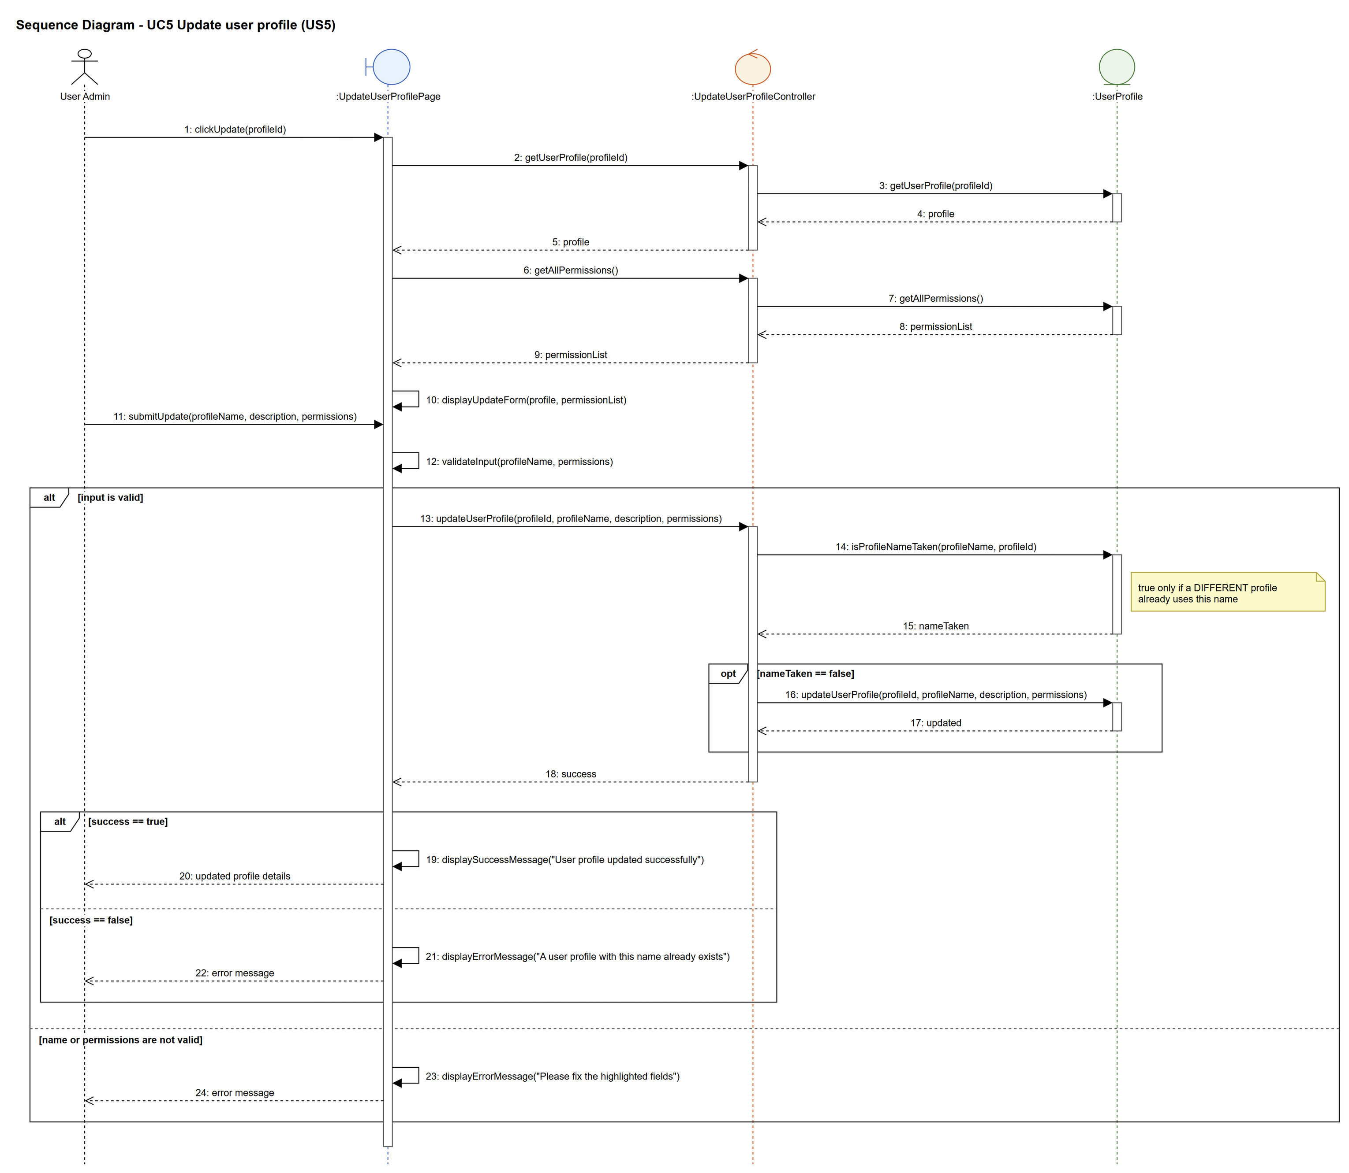
Figure 7: Sequence diagram for UC5 Update user profile

7. Test cases
Test data used below: user profiles User Admin (id 1), Interior Designer (id 2), Customer (id 3) and Platform Manager (id 4), all Active. User accounts admin01 / Admin@123 (User Admin, Active), admin02 / Admin@123 (User Admin, Suspended), des001 / Des@123 (Interior Designer, Active) and cust001 / Cust@123 (Customer, Active).

7a. System test cases (black box)
Equivalence partitioning and boundary value analysis were used to pick the test data. Fill in "Actual result" and "Pass/Fail" after running each test.
Test ID | Scenario | Prerequisites | Test steps | Test data | Expected result | Actual result | Pass / Fail
TC5.1 | Form is filled in with the current details | Logged in as admin01, viewing Interior Designer. | 1. Click "Update" | Profile: Interior Designer (id 2) | The form shows the current name, description, and Manage company profile + Manage own IDPs ticked.
TC5.2 | Add a permission | Same as TC5.1. | 1. Click "Update"  2. Tick "View IDP statistics"  3. Click "Save changes" | Permission added: View IDP statistics | "User profile updated successfully". The details page lists 3 permissions.
TC5.3 | Remove a permission | TC5.2 done. | 1. Click "Update"  2. Untick "View IDP statistics"  3. Click "Save changes" | Permission removed: View IDP statistics | Saved. The details page lists 2 permissions again.
TC5.4 | Change the description, keep the same name | Same as TC5.1. | 1. Click "Update"  2. Change the description  3. Click "Save changes" | Description: Designers who show their company, IDPs and statistics | Saved. Not treated as a duplicate name.
TC5.5 | Rename to a new name | No profile called Designer. | 1. Click "Update"  2. Change the name  3. Click "Save changes" | Name: Designer | Saved. The list shows Designer instead of Interior Designer.
TC5.6 | Rename to a name another profile uses | The Customer profile exists. | Same as TC5.5 | Name: Customer | "A user profile with this name already exists". Nothing changes.
TC5.7 | Name cleared | Same as TC5.1. | Same as TC5.5 | Name: (empty) | "Profile name must be 3-50 characters". Nothing changes.
TC5.8 | Name 51 characters | Same as TC5.1. | Same as TC5.5 | Name: "B" typed 51 times | Same error as TC5.7. Nothing changes.
TC5.9 | All permissions unticked | Same as TC5.1. | 1. Click "Update"  2. Untick every permission  3. Click "Save changes" | Permissions: (none) | "Tick at least one permission". Nothing changes.
TC5.10 | Cancel | Same as TC5.1. | 1. Click "Update"  2. Change the name  3. Click "Cancel" | Name: Something Else | Back on the details page. Nothing changed.
TC5.11 | Update a suspended profile | The Customer profile is Suspended. | 1. View Customer  2. Click "Update"  3. Change the description  4. Click "Save changes" | Description: Home owners who are renovating | Saved. The status is still Suspended.

7b. Unit test cases (for TDD)
These are written before the code (test-driven development) and run automatically in the CI pipeline. They cover normal inputs, abnormal inputs and boundary values.
Test ID | Class and method | Input / setup | Expected output | Type | Pass / Fail
UT5.1 | UserProfile.isProfileNameTaken() | "Interior Designer", 2 | Returns false (its own name) | Normal
UT5.2 | UserProfile.isProfileNameTaken() | "Customer", 2 | Returns true | Abnormal
UT5.3 | UpdateUserProfileController.updateUserProfile() | 2, "Interior Designer", "Designers who show their company, IDPs and statistics", [3 permissions] | Returns true. getUserProfile(2) returns the new description and 3 permissions. | Normal
UT5.4 | UpdateUserProfileController.updateUserProfile() | 2, "Customer", "", ["Manage own IDPs"] | Returns false. Profile 2 is unchanged. | Abnormal
UT5.5 | UpdateUserProfileController.updateUserProfile() | 9999, "Ghost", "", ["Generate reports"] | Returns false (no error thrown) | Abnormal
UT5.6 | UpdateUserProfileController.updateUserProfile() | 2, "", "", ["Manage own IDPs"] | Returns false | Abnormal
UT5.7 | UpdateUserProfileController.updateUserProfile() | 2, "Interior Designer", "", [ ] | Returns false | Abnormal
UT5.8 | UpdateUserProfileController.updateUserProfile() | 3 (Customer, Suspended), "Customer", "Home owners who are renovating", ["Search, view and save IDPs"] | Returns true. The status is still "Suspended". | Normal
UT5.9 | UpdateUserProfilePage.validateInput() | 51-character name, ["Manage own IDPs"] | Returns false | Boundary

